|  |
| --- |
| KIIT(sponsor).png |
| A project report on |
| **KIIT e-LIBRARY MANGEMENT SYSTEM** |
| Submitted in partial fulfillment of the requirements for the Degree of |
| B. Tech in Computer Science And System Engineering |
| by |
| **Abhirashmi Kumari (1828223)**  **Nitiksha Darshana (1828171)** |
| under the guidance of |
| **Prof. Satarupa Mohanty** |
| School of Computer Engineering |
| Kalinga Institute of Industrial Technology Deemed to be University  Bhubaneswar |
| March 2021 |

|  |  |
| --- | --- |
|  | |
| **CERTIFICATE**  This is to certify that the project report entitled **“KIIT e-LIBRARY MANGEMENT SYSTEM”** submitted by  **Abhirashmi Kumari 1828223**  **Nitiksha Darshana 1828171**  in partial fulfillment of the requirements for the award of the **Degree of Bachelor of Technology** in **Discipline of Engineering** is a bonafide record of the work carried out under my(our) guidance and supervision at School of Computer Science And Engineering, Kalinga Institute of Industrial Technology, Deemed to be University. | |
|  | Dr.Satarupa Mohanty Professor,  KIIT,DU |
| ................................................................................................................................................ | |
| **The Project was evaluated by us on 14/05/2021** | |
| EXAMINER 1 | EXAMINER 2 |
| EXAMINER 3 | EXAMINER 4 |

# ACKNOWLEDGEMENTS

|  |
| --- |
| We take this occasion to thank God, almighty for blessing us with his grace and taking our endeavor to a successful culmination. We extend our sincere and heartfelt thanks to our esteemed guide, **Prof.Satarupa Mohanty**, for providing us with the right guidance and advice at the crucial junctures and for showing us the right way.  We also take this opportunity to express a deep sense of gratitude towards the Dean of Computer Science and Engineering .  We would like to thank our friends and family for the support and encouragement they have given us during the course of our work. |
| **Abhirashmi Kumari (1828223)**    **Nitiksha Darshana (1828171)** |

ABSTRACT

KIIT e-Library Management System is a system which maintains the information about the books & materials present in the library, their authors, the members of library to whom books are issued, library staff and all. This is very difficult to organize manually. Maintenance of all this information manually is a very complex task.

Owing to the advancement of technology, organization of an e-Library becomes much simple. The e-Library Management has been designed to computerize and automate the operations performed over the information about the members, book & material issues, and returns & all other operations.

This computerization of library helps in many instances of its maintenances. It reduces the workload of management as most of the manual work done is reduced and helps the students to find a better opportunity admist the Pandemic Situation.

TABLE OF CONTENTS

|  |
| --- |
|  |
| Abstract  CHAPTER 1: INTRODUCTION  CHAPTER 2: BACKGROUND/BASIC CONCEPTS  CHAPTER3: PROJECT ANALYSIS/ PROJECT IMPLEMENTATION CHAPTER 4: RESULTS AND DISCUSSION  CHAPTER 5: CONCLUSION & FURTHER WORK  REFERENCES |

**CHAPTER 1 INTRODUCTION**

This chapter gives an overview about the aim , objectives ,background and operation environment of the system.

**PROJECT AIMS AND OBJECTIVES**

The project aims and objectives that will be achieved after completion of this project are discussed in t his subchapter. The aims and objectives are as follows:

Can create a computerized management system for a library Has the capability to issue books

Has the capability to return books Has an administrator account

Can manage users through administrator account Has customized profile with photo of the user Tracks the books that users have issued

Keeps the databases correct and up-to-date

Can store all the book and user data in a proper manner

### Document Conventions

The following are the list of conventions and acronyms used in this document and the project as well:

**Admin:** A login id representing a user with user administration privileges to the software

**User:** A general login id assigned to most users

**Client:** Intended users for the software

**SQL:** Structured Query Language; used to retrieve information from a database

**SQL Server:** A server used to store data in an organized format

**ASP:** Active Server Pages: A Web Page formatted on the server and delivered to the browser.

**Layer:** Represents a section of the project

**User Interface Layer:** The section of the assignment referring to what the user interacts with directly.

**Application Logic Layer:** The section of the assignment referring to the Web Server. This is where all computations are completed.

**Data Storage Layer:** The section of the assignment referring to where all data is recorded.

**Data flow diagram:** It shows the dataflow between the entities.

**Use Case:** A broad level diagram of the project showing a basic overview

**Boolean:** A true/false notation

**Interface:** Something used to communicate across different mediums

**Unique Key:** Used to differentiate entries in a database

**CHAPTER 2 BACKGROUND**

E-Library Management System is an application which refers to library systems which are generally small or medium in size. It is used by librarian to manage the library using a computerized system where he/she can add new books, videos and Page sources.

Books and student maintenance modules are also included in this system which would keep track of the students using the library and also a detailed description about the books a library contains. With this computerized system there will be no loss of book record or member record which generally happens when a non-computerized system is used.

All these modules are able to help librarian to manage the library with more convenience and in a more efficient way as compared to library systems which are not computerized.

### Hardware Requirements

◻ Ram 2GB or Higher

◻ Memory

### Software Requirements

◻ OS - Windows7 or higher

◻ Apache server

◻ Database

◻ MySQL

◻ PHP , XAMP

The following web pages constitute the ‘KIIT e- Library Management’ website Main Page

* Consisting of the WELCOME and REGISTRAION columns Login Page
* Includes an interface to Login both for users and administrator
* A forgot password facility Admin Page
* Includes links to other pages: ‘Add Books’, ‘Remove Books’,‘Manage Users’
* Has a welcome page with profile options
* A Log out tab User Page
* Includes links to other pages: ‘Issue Books’, ‘Account’, ‘Return Books’
* And a welcome page with profile options
* A Log out tab

Following are some of the basic attributes that the project should have:-

**Reliability: -** The system should be reliable in the sense that there should be no room for mistakes. Every activity/ function of project should be indefectible.

**Availability**: - The system is to be available as and when needed. **Security**: - The system is to be secure in the sense that nobody except the authenticated users can login and use the system.

**Portability**: - The project should be made such that there are as less operating system dependencies as possible, or the software should be portable with only few modifications.

**Maintainability**: - The system should be maintainable in the sense that if any error occurs, it should be easily rectified and the cost incurred in maintenance should be as low as possible.

### Organizing Specific Requirements

There are some requirements of the system that are indispensable while the others are lesser. Following is the organization of specific requirements in descending order of their importance: -

i.) Functional requirements. Higher ii.) External Interface requirements. iii.) Performance requirements.

iv.) Design Constraints.

v.) Logical Database requirements. vi.) Software system attributes. Lower 13

### Description

The user interface must be customizable by the administrator

### Criticality

This issue is essential to the overall system. All the modules provided with the software must fit into this graphical user interface and accomplish to the standard defined.

### Technical issues

In order to satisfy this requirement the design should be simple and all the different interfaces should follow a standard template. There will be the possibility of changing colors and images, plus switching between interfaces with the minimum impact for the users.

### Risks

To reduce the circumstances under which this requirement might not able to be satisfied, all the designers must have been developed web sites previously and they must be aware of html restriction and cross browsers implementations before starting the designing. In order to reduce the probability of this occurrence the entire design team will be trained in basic html development and macromedia fireworks, this tool will be used instead of Photoshop.

### Dependencies with other requirements

All user interfaces should be able to interact with the user management module and a part of the interface must be dedicated to the login/logout module.

ER Model -

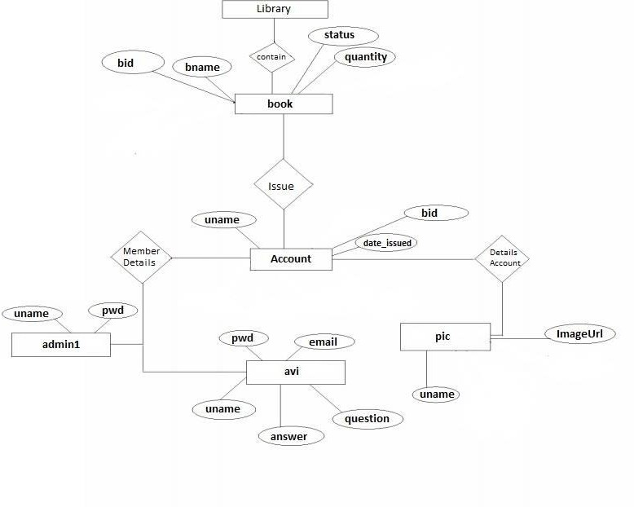

## CHAPTER 3 PROJECT ANALYSIS/ PROJECT IMPLEMENTATION

### Flaws in Existing System:

* + Early days Libraries are managed manually. It required lot of time to record or to retrieve the details. The employees who have to record the details must perform their job very carefully. Even a small mistake would create a lot of problems. Security of information is very less. Report generations of all the information is very tough task.
  + Maintenance of Library catalogue and arrangement of the books to the catalogue is very complex task. In addition to its maintenance of member details, issue dates and return dates etc. manually is a complex task.
  + All the operations must be performed in perfect manner for the maintenance of the library without any degradation which may finally result in the failure of the entire system.

### Proposed System:

To solve the inconveniences as mentioned in the existing system, an **e-Library** is proposed. The proposed system contains the following features:

* The students will register them through Online
* Individually each member will have his account through which he can access the information he needs.
* Book details like authors, number of copies totally maintained by library, present available number of books, reference books, non-reference books etc. all this information can be made handy.
* Regarding the members designation, number of books was issued.
* Issue dates and returns of each member is maintained separately and fine charged if there is any delay in returning the book.
* Administrator can add, update the books.
* Time consuming is low, gives accurate results, reliability can be improved with the help of security.

### FEASIBILITY STUDY

In feasibility study phase various steps have been taken:

1. Identify information at different levels.
2. Identify the expectation of user from an automated system.
3. Analyze the importance of automated system

### Feasibility study:

In order to make sure that the project is feasible, following feasibility studies have been conducted: -

### Technical Feasibility study:

It is possible to develop the system using simple platform. All the functions of a project for communication can be implemented in the new system. Hence the system is technically feasible.

### Economic Feasibility study:

College library management system is a worth making project. This project is economically feasible in every sense that it takes less effort, less time, and nominal cost of purchasing the tools for developing the software.

### Legal feasibility study:

Since the project needs no copyright, patenting, and doesn’t intent to have any relation with anybody else’s intellectual property rights, it can be considered as a legally feasible project.

### Time feasibility study:

As it has been more probable (as per the requirements, functions, and performance specifications of the system) that the project can be completed within the given time 7

frame, it is considered that the undertaking this project is feasible in the context of time.

### Operational feasibility study:

This system is completely operational and can be successfully implemented. College library management system is easy to understand not only for any sophisticated users but for the naïve users as well .It provides simple ambience in which user can feel free to work faster, easier, and more accurately. Therefore, it can be socially and behaviorally accepted and is feasible too.

### Project planning:

During Planning all the activities that are to be performed to create the system are planned. Following are some of the issues that are well devised so that proper monitoring and controlling of the project could be easily done: -

### Project development:

To avoid being stuck in dilemma during the development of project, one need to be sure that the process model he’s using is right for the project. Since all the requirements about the problem can’t be easily understood and may not be stable during the development of the system.

### Quality Planning:

To ensure that the final software for-“College library management system” is of high quality, some quality control activities should be decided /planned in advance to perform them throughout the development of the software.

Following is a list of quality control activities that are used to identify and remove defects from the software, hence making it a high quality controlled system: - Requirements Review

Design Reviews Code Reviews Testing

8

### Risk control planning:

A risk is a probabilistic event – it may or may not occur. The aim of risk control planning is to minimize the impact of risks (if they occur) in the project.

Following are some known risks that might occur and their mitigation plan: - Unclear project requirements **~>** Keep in touch with the faculty in charge.

Data loss **~>** Use CD’s and/or pen drives to have some extra backups of the data. Project delays **~>** Use proper scheduling of the project as soon as possible so that the project could be completed.

### Software size planning:

It has been taken into account that there are some functions in project that are indispensable .And these should not be excluded from project .Such functions

/modules are like login, Sign up, admin add, admin remove, add user, remove user. So there are at least a minimum number of modules that have to be there in project.

THE DATABASE DIAGRAM-

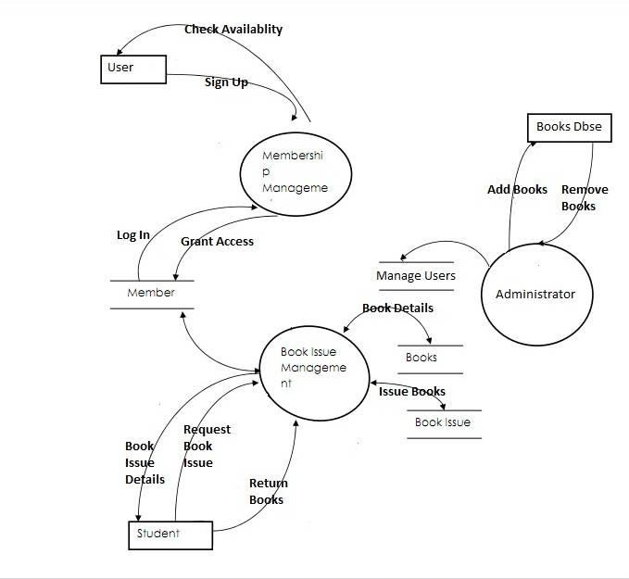

## CHAPTER 4 RESULTS & DISCUSSIONS

This website provides a computerized version of library management system which will benefit the students as well as the staff of the library.

It makes entire process online where student can search books, staff can generate reports and do book transactions. It also has a facility for student login where student can login and can see status of books issued as well request for book or give some suggestions. It has a facility of teacher’s login where teachers can add lectures notes and also give necessary suggestion to library and also add info about workshops or events happening in our college or nearby college in the online notice board.

There is a future scope of this facility that many more features such as online lectures video tutorials can be added by teachers as well as online assignments submission facility, a feature Of group chat where students can discuss various issues of engineering can be added to this project thus making it more interactive more user friendly and project which fulfills each users need in the best way possible.

### Product Perspective:

College library management system is a product which does not intent to have any relation with any other product. It is a complete system in itself. It is an exclusive product which is to be concerned with the optimization.

### Product Features:

The project mainly use the concepts of .Net, simple tools of programming and SQL server for database storage

### User Classes and Characteristics

There are number of functions that the system/product is supposed to perform which is as follows: -

Issue books Remove books Admin login User login Add books Welcome page New user

The user of this product need not be computer expert. Even a naïve user can also operate the system. The user interfaces are to be made so simple that anybody can be comfortable in working with the system in just a few minutes. The basic things which are required in a user are:

User should know what the computer is. User should understand English.

User must know which key (button or keyboard) does what. User must have an experience of library management.

### Operating Environment:

The product will be operating in windows environment. Also it will be compatible with the higher version of this explorer.

### Design and Implementation Constraints:

The general constraints which are to be introduced in project are as follows: -

Only that person can operate the systems who knows the ID and Password of the valid user of the system.

In case admin does not remembers his/her ID/Password then system won’t consider him/her as a valid user for College library management system.

## CHAPTER 5 CONCLUSION AND FUTURE WORK

* 1. Conclusion

Students Faculties & Staff will have equal beneficiary over the platform. Maintenance of Records and Personal Data will be handled in simpler ways.

One -Stop Solution for all academic need.

* 1. Future Work

Addition of Features like Recorded Videos , Competitive Materials and Placement Preparation Tools/Materials and User Rating System.

5. 3 Planning And Project Management

**Table 5.1 showing details about project planning and management**

|  |  |  |
| --- | --- | --- |
| **Activity** | **Starting week** | **Number of weeks** |
| Literature review | 4th Week of Febuary | 1 |
| Finalizing problem | 1st week of March | 2 |
| Excuting and Finalizing the Set of codes | 3rd week of March | 1 |
| Preparation of project report and Implementation of Software | 1st week of April | 1 |
| Preparation of project presentation | 2nd week of April | 1 |

### REFERENCES

Notes of Ms. Biji Elizabeth

Website for usage of templates: [www.freewebtemplates.com](http://www.freewebtemplates.com/) For querying a doubt: [www.google.com](http://www.google.com/)

For knowledge on ASP.net through [www.roseindia.net](http://www.roseindia.net/) <http://www.w3schools.com/html/html_intro.asp> <http://www.Udemy.com/css/css_background.asp> <http://www.w3schools.com/js/js_datatypes.asp>

### CONCLUSION

After we completed the project we were sure the problems in the existing system are overcome. The **“KIIT e-LIBRARY MANAGEMENT SYSTEM”** process made computerized to reduce human errors and to increase the efficiency. The main focus of this project is to lessen human efforts. The maintenance of the records is made efficient, as all the records are stored in the ACCESS database, through which data can be retrieved easily. The editing is also made simpler. The user has to just type in the required field and update the desired field.

Our main aim of the project is to get the correct information about a particular student and books available in the library.

The problems, which existed, have been removed to a large extent. And it is expected that this project will go a long way in satisfying user’s requirements. The computerization of the Library Management will not only improve the efficiency but will also reduce human stress thereby indirectly improving human recourses

**INDIVIDUAL CONTRIBUTION REPORT:**

## KIIT e-Library Management System

Abhirashmi Kumari 1828223

**Abstract:** The Uniqueness of the project lies in thoughts and data putted into it. The project is trying to settle the previous flaws , which was faced in the e-Library through modern concepts and virtualizations.

**Individual contribution and findings:** I have done the whole backend , frontend part and making databases , connection to the servers with each page of the websites , individual pages and user interface basically the styling and outlook of the website. (Backend developer + UI developer). Fixing the errors and designing of the whole website front end and backend . Created the panels both for user and admin . And adding diffrent features to the websites.

**Individual contribution to project report preparation**.

I have helped in collecting the literature required and framed the set of codes , implementation and compilations along with debugging and error handling.

**Individual contribution for project presentation and demonstration**

Explanation of the Codes ,helped in collecting the literature , ER diagrams , Future Compilation and Error Fixations

Full Signature of Supervisor: Full signature of the student:

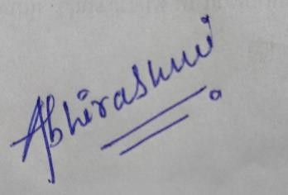

……………………………. ……………………………..

# TURNITIN PLAGIARISM REPORT

